DCN Practical Assignment 3

Designthefollowingtopologies.
Bus Topology

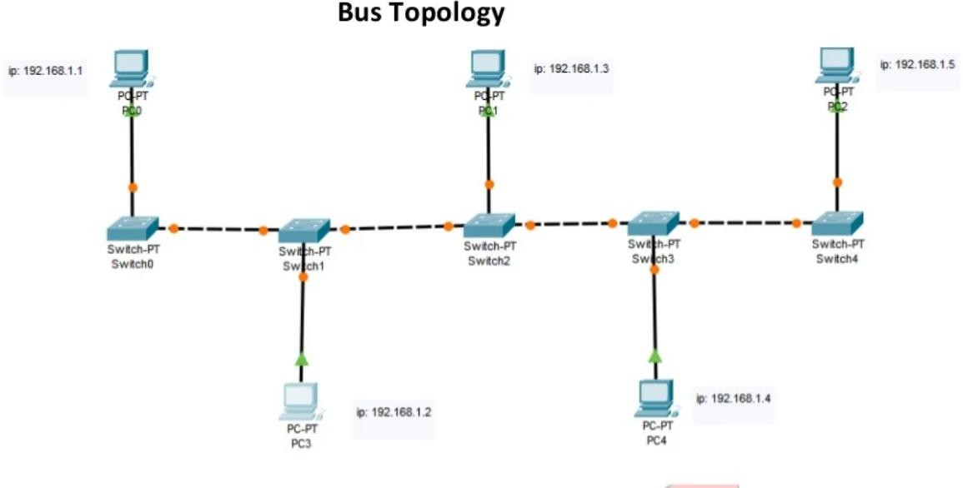
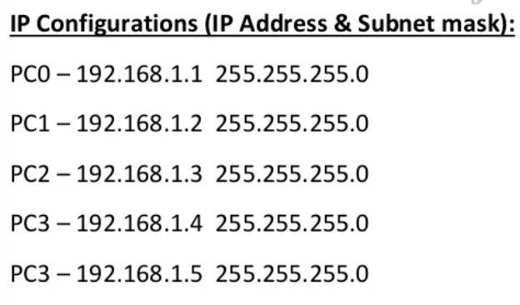

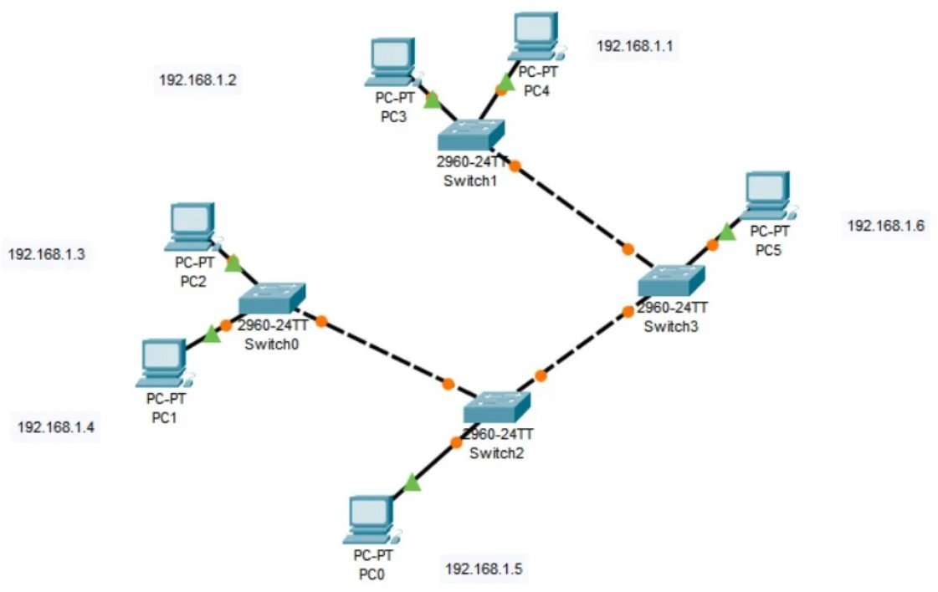

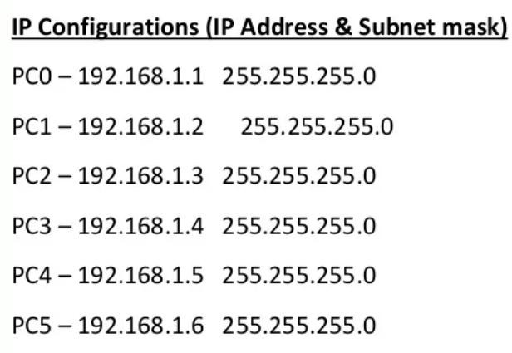

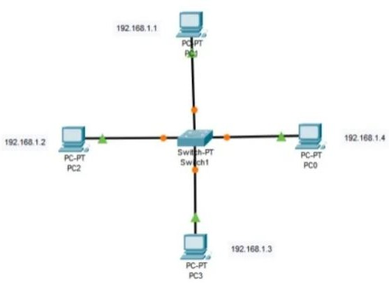

IPConfigurations(IPAddress&Subnetmask)

PC0–192.168.1.1 | 255.255.255.0
PC1–192.168.1.2 | 255.255.255.0
PC2–192.168.1.3 | 255.255.255.0
PC3–192.168.1.4 | 255.255.255.0

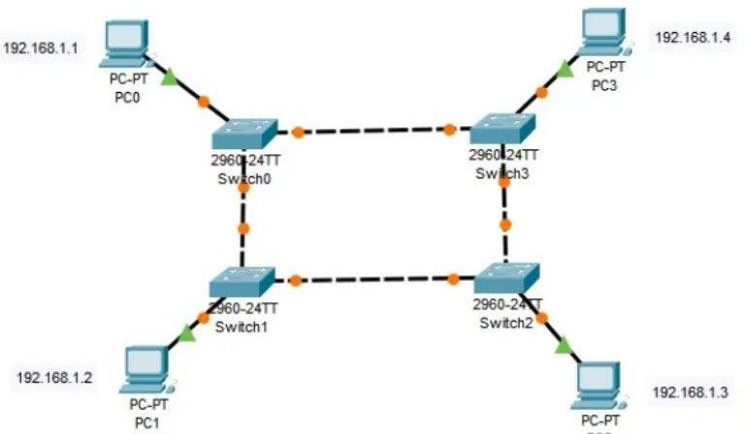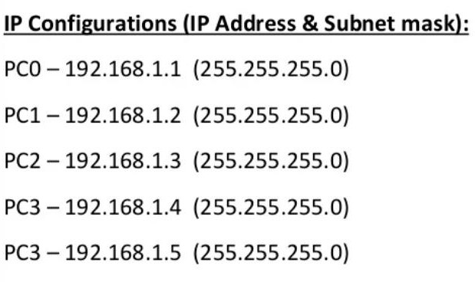

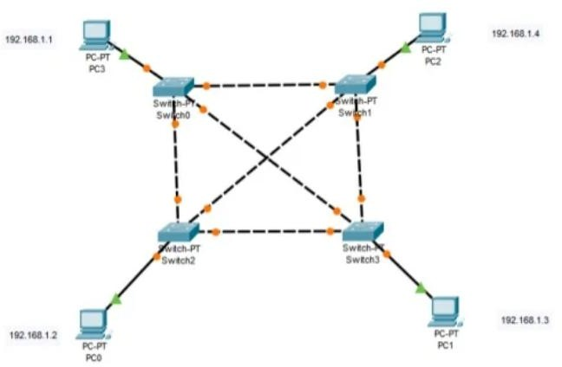
IPConfigurations(IPAddress&Subnetmask)

PC0–192.168.1.1 | 255.255.255.0
PC1–192.168.1.2 | 255.255.255.0
PC2–192.168.1.3 | 255.255.255.0
PC3–192.168.1.4 | 255.255.255.0

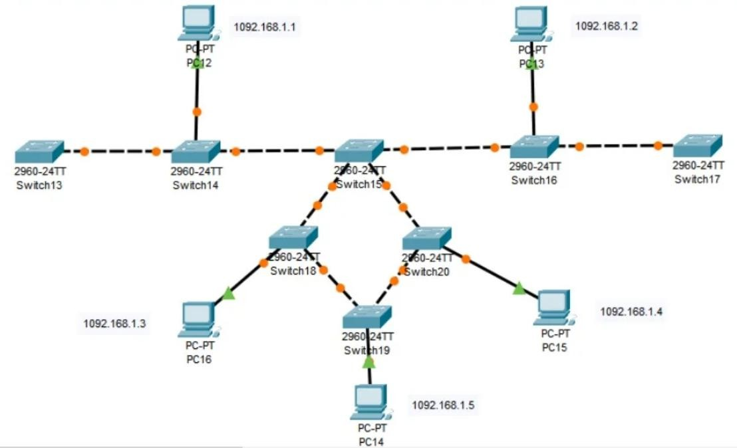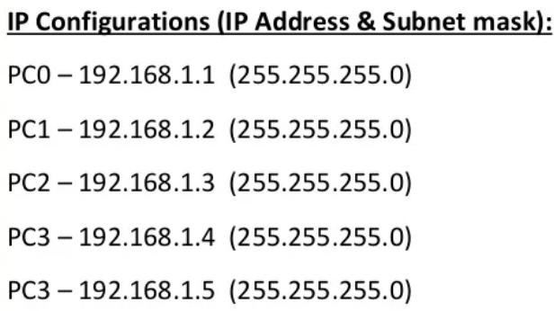

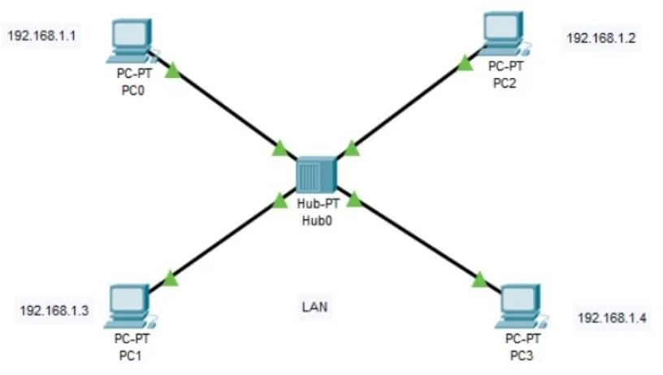

MAN

